
BASIC 2 – MATERIAL COMPILATION
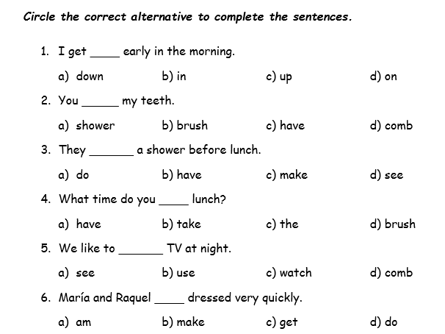

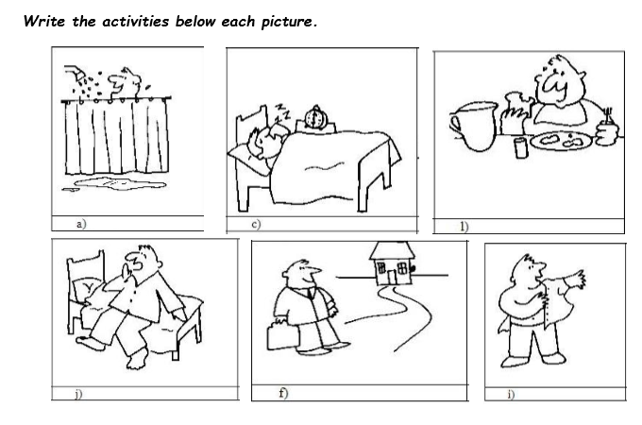

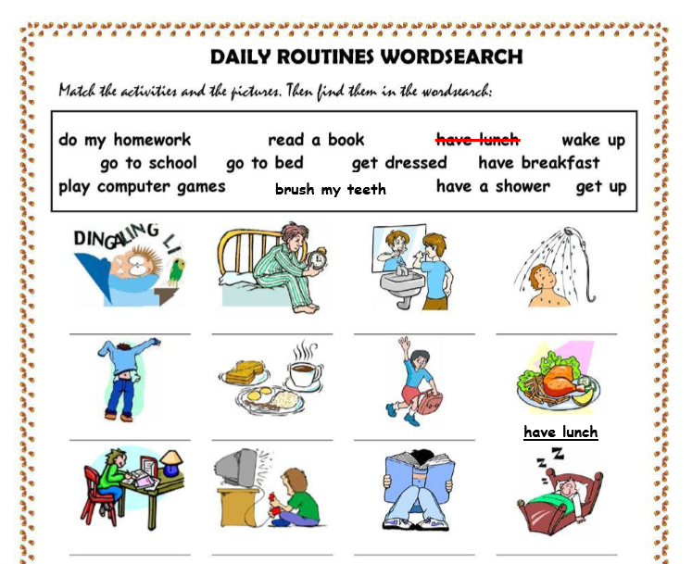

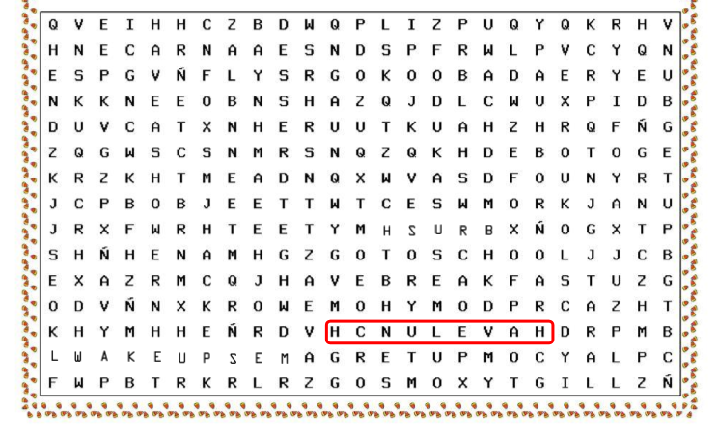

PRESENT SIMPLE:

- Complete Steve’s daily routine using the verbs in brackets.

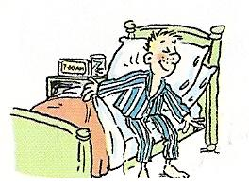  Steve __________ (wake up) at 7:30am. |   He __________ (get dressed) and ________ (have) breakfast at 8 o’clock. | 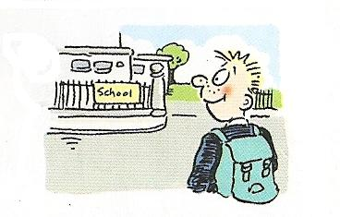  Then, he _______ (go) to school at 8:45am.
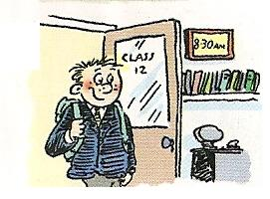  Lessons _______ (start) at 9 o’clock. | 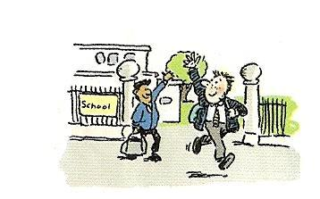  Steve usually _______ (finish) school at 3:30pm |   In the afternoon, he _______ (do) his homework.
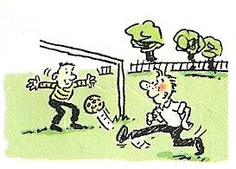  He sometimes ________ (play) soccer with his best friend. |   Before dinner he _______ (watch) his favorite programme on TV. |   Steve and his mother usually _______ (have) dinner at 8:30pm.
  After dinner, Steve _______ (play) computer games until bedtime. | 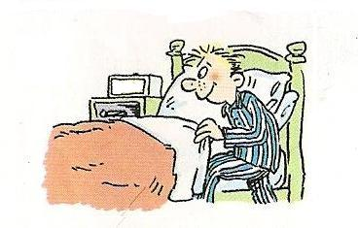  Finally, he ________ (brush) his teeth and _______ (go) to bed.

