
BASIC 1 – MATERIAL COMPILATION

GREETINGS:
- Complete the conversation using the words in the box.
HOW – NAME – NICE – TOO – GOOD – BYE – THANKS - MEET

A: _________ morning. ______ are you today?
B: Fine, _________. And you?
A: Excellent! What’s your _____________ ?
B: I’m Gabriel, and you?
A: My name’s Andrea.
B: _______ to meet you.
A: Nice to ______ you ______. See you.
B: _________.
- Put the words in order to form phrases.

to / nice / you / too / meet
_________________________________________________

Paul / this / my / is / friend / Hi / Andrea
_________________________________________________

Augusto / how / going / hello / it / is ?
_________________________________________________

pleasure / it / a / is / meet / you / to
_________________________________________________

- Fill in the blanks to complete the conversation.

A: H______o Nicky!
B: Hi Robert! How’s e_____________?
B: G_______! And you, _______ are you?
A: F______, t________. It’s nice to see you.
B: It’s n_____ to see you, t___.
A: G_________!
B: S_____ y_____!
COUNTRIES & NATIONALITIES:
- Write the nationalities of the following people.
- Pablo is from Spain. He’s __________________.
- I’m from Peru. I’m ________________________.
- Rosa and Gustavo are from Italy. They’re _______________.
- Xing, Thou and me are from China. We’re ______________.
- My mother is from the UK. She’s _____________________.
- He’s from Turkey. He’s ____________________.
- You’re from Greece. You’re ________________.

NUMBERS:
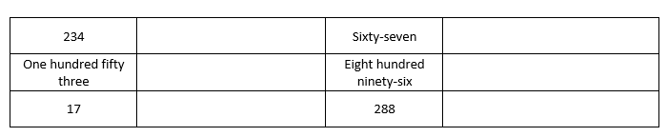
- Complete the table using letter or numbers.

- Write the numbers next to their names:

Twenty-one →
Fifty →
One hundred →
Two hundred sixty-seven →
Twelve →
Ninety-nine →
Forty-five →
Thirteen →

- Complete the names of the numbers:

56 → f _ _ ty – s _ x
310 → t _ r _ _ h _ _ _ red t _ n
80 → e _ _ ht _
15 → f _ _ _ een
72 → se _ _ _ t _ - t _ _
40 → f _ _ _ _
37 → t _ _ r _ _ - _ _ v _ n
11 → e _ _ _ _ n

COLORS:
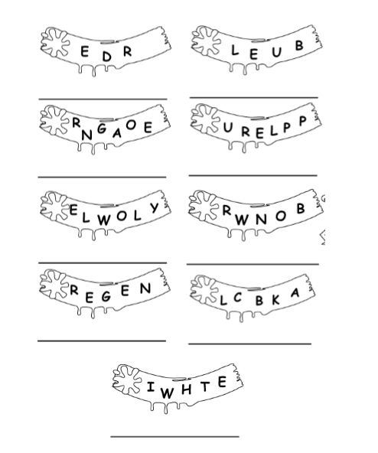
- Unscramble the letters and color the labels.

OCCUPATIONS:
- Put the letters in order to form occupations. Add a/an to each word.
For example: H E C F → a chef

- R A C H T I E C T → _____ __________________
- S U I C N A M I → ______ ___________________
- G T E F R E I F H I → _____ ___________________
- G O T H P A E R P O H → ____ _________________
- C T Y R A S E E R → ____ ______________
- U S B R I E D V R → ____ ____________
- O L P I C E F E R F O I C → ____ _________________
- X A I T V R D I E R → ____ ___________________
- E L S S P A R O S N E → _____ _________________

WRITING THE DATE:
- Write the following dates using letters:
For example: 6TH MAR → the sixth of March
- 20TH FEB → ________________________________
- 1ST APR → ________________________________
- 12TH OCT → ______________________________
- 3RD SEP → _______________________________
- 9TH JAN → ______________________________
- 8TH DEC → _____________________________

FAMILY:
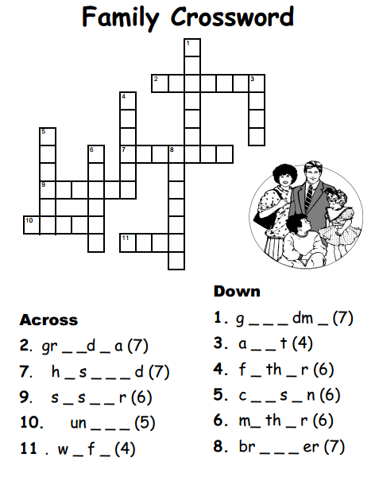

VERB TO BE:
- Write the correct form of the verb BE:
- It ______ cold today.
- I ______ at home now.
- They ______Korean.
- My name ________ Nikita.
- We _______ from Ukraine.
- I _______OK, thanks.
- Clara and Steven ______ married.
- Put the words in order to make sentences:
I / old. / years / am / twenty-five

________________________________________
are / from / We / Venezuela.

___________________________________________
name / I'm / My / Anton / is / a / student./ and

_________________________________________

book./ my / This / is

___________________________________________
today. / It's / day / a / nice

___________________________________________

Her / name / brother's / is / Paul.

_______________________________________________

